Contents

A. Social Hub Configuration widget 1
B. Creating the individual checklist items 1
1. Custom Page - Text 1
2. Custom Page – Link(s) 3
3. Surveys 5
3.1. Creating a new survey 5
3.2. Editing a survey 8
C. Landing page configuration 9
D. Staff Grouping 11
E. Adding items to the Checklist 13
1. Adding an Input item 13
4. Adding a UDF item 16
5. Adding a survey 17
F. Restricting access to tasks using the Staff Groups 17
G. Activate 18

Background
The creation of an onboarding checklist was approved and prioritised by the Personnel POG in 2022.

The checklist is accessed in the Social Hub via Employee Self Service.

Social Hub Configuration widget
In order to configure On and offboarding the Social Hub Configuration widget must be enabled.

Administrator Dashboard > Admin > Site Manager >Dashboard Configuration

- Select the Administrator Dashboard

- Select the Admin tab and search for ‘Social Hub Configuration’

- Toggle ON

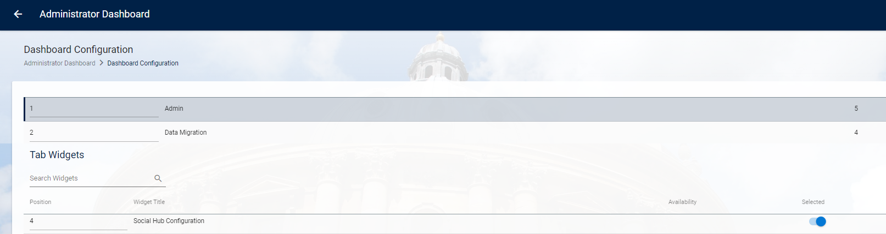

- If required select the position. (It is currently configured at position 4)

Creating the individual checklist items

Custom Page - Text

Administrator Dashboard > Admin > Social Hub Configuration > Maintain Custom Pages

- Click on VIEW

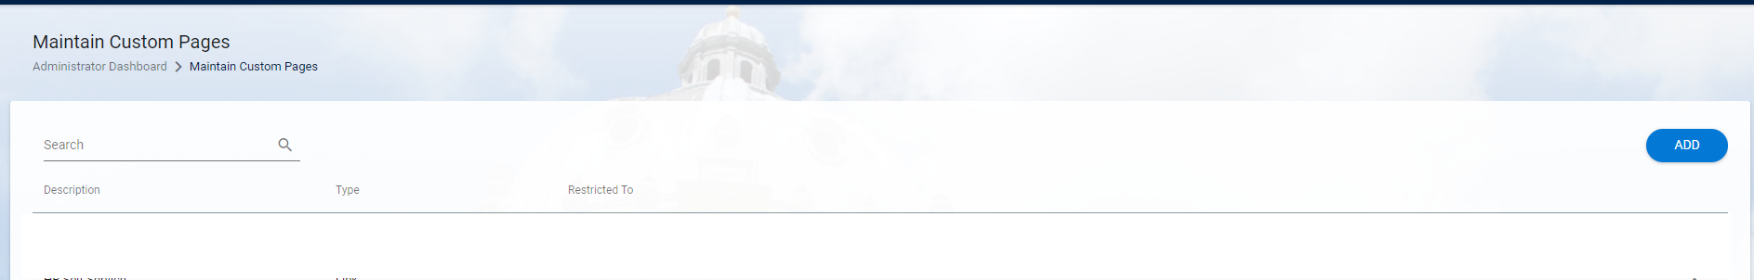

- Click on ADD  - Description* enter a Description (Max 100 characters) |  | 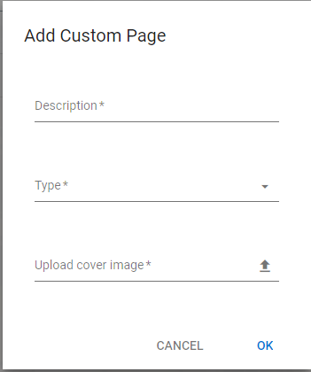
- Type* - Choose 'Text' from the drop-down list |  | 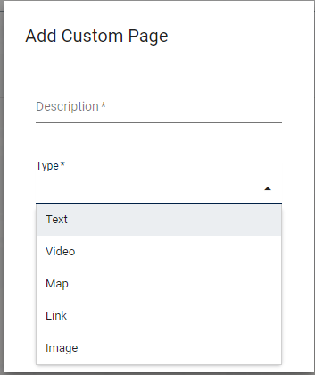
- Upload cover image - click on the to browse. Once you've located the image to upload, select it and click on 'Open' (or double click) to upload it.

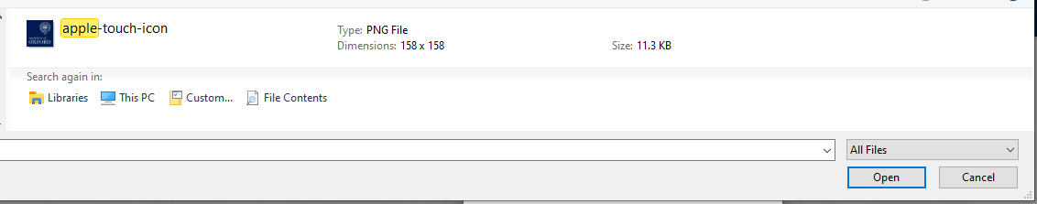

 | NB: The file type must be .png

- Click OK.

The Edit Custom Page window will open

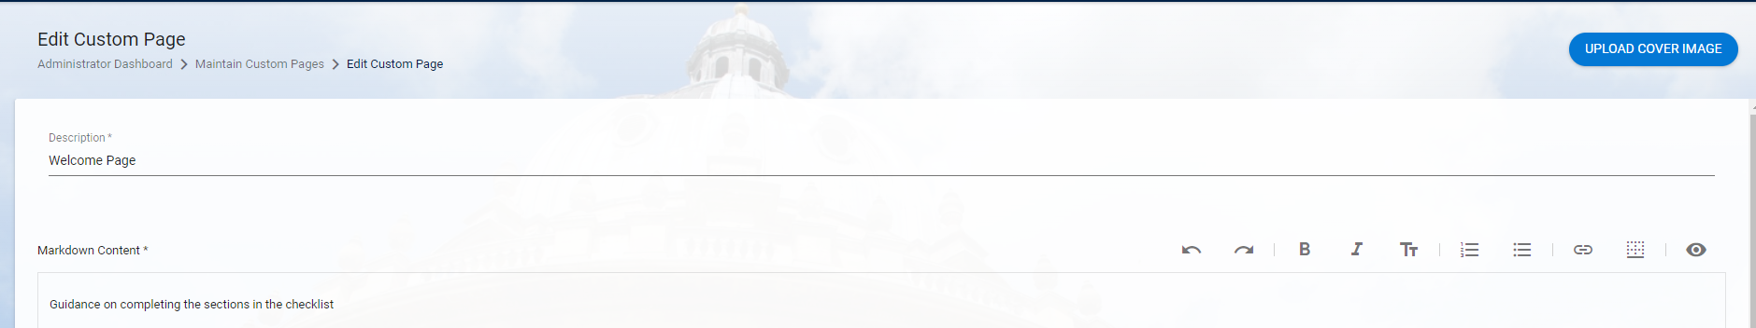

- Markdown Content* - Enter required text (limit = 2500 characters)

- SAVE

Custom Page – Link(s)

Administrator Dashboard > Admin > Social Hub Configuration > Maintain Custom Pages

- Click on VIEW

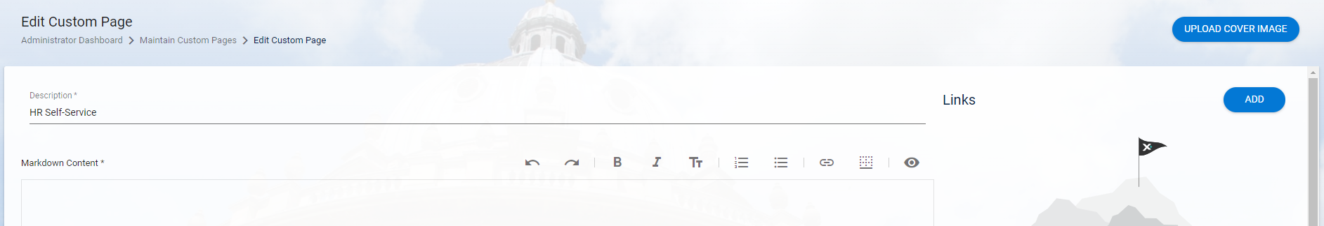

- Click on ADD  - Description* enter a Description (Max 100 characters)  - Type* - Choose 'Link' from the drop-down list |  | 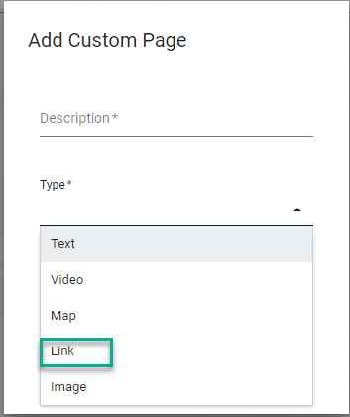  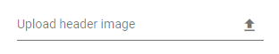
- Upload cover image - click on the to browse. Locate the image to upload, select it and click on Open (or double click) to upload it.



 | NB: The file type must be .png

- Click OK.

The Edit Custom Page window will open.



- Markdown Content* - Enter required text (limit = 2500 characters)

- Click on ADD to insert hyperlinks  - Enter the Title*  - Enter or paste the URL*  - Click OK to return to the editing screen |  | 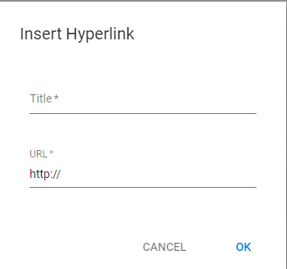

- The links will appear on the right hand side of the page. Click on the ellipses to edit or delete.

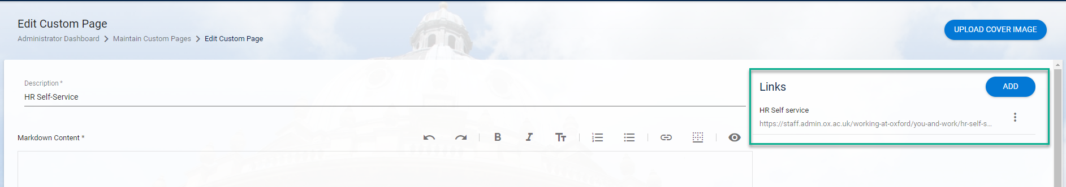

- Repeat for each URL to be added.

- SAVE

Surveys

Creating a new survey

Administrator Dashboard > Admin > Social Hub Configuration > Surveys

- Click on VIEW

- Click on ADD  - Description* enter a Description (Max 100 characters)  - Type* - Select Onboarding (Or Off-boarding where applicable)  - Upload header image (optional) – upload an image if required (not tested)  - Click OK |  | 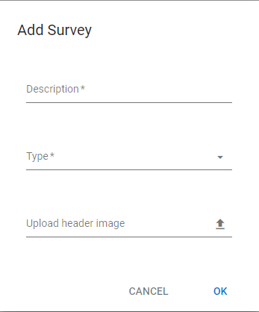
In the Add a new Section window:  - Section Name* - Enter a name/title  - Layout* - Choose Row or Column |  | 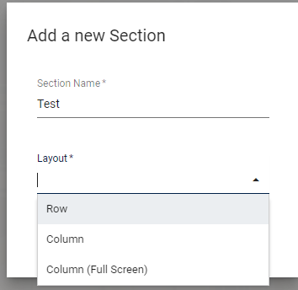
 | NB: When creating surveys, the agreed format is that one section should be configured as Columns, two or more should be configured as Rows

 | NB: A survey must have at least one section. A section must have at least one field. Fields form the questions that will be included in the survey and can be configured to enable different response types e.g. Yes/no, date, free text.

- Click on ADD FIELD

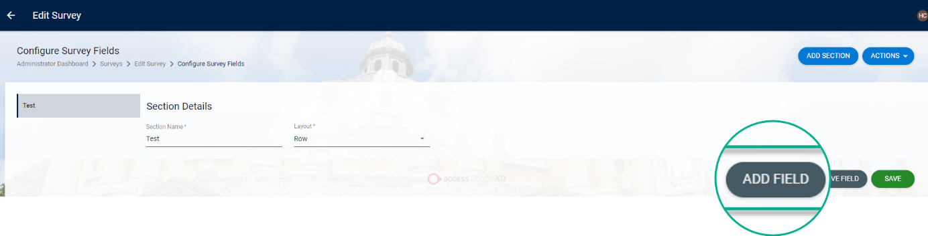

- Field Name* - Enter a name for the field |  | 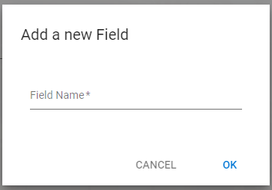

- Type of Field * - Select from the drop-down list (See answer options section)

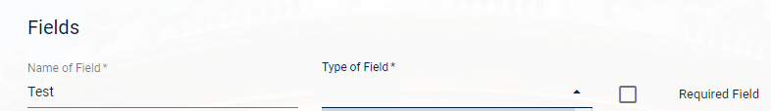

- Required Field – Tick if a response to this question is mandatory

Answer Options

There are several different options to select from for 'Type of Field' depending on the type of answer required for each question in the survey.

The following options are configured as shown in steps 10 to 12 above.  Text Field – allows a short text response  Text Area – allows a longer text response  Date Field – enables a calendar to choose a date from or the date can be entered manually  Number Field – allows a numeric response |  | 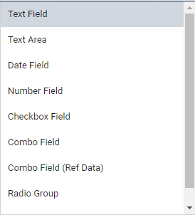

The remaining options require further configuration as shown below:

Combo field – allows manual entry of possible responses that can be selected from when completing the survey. Multiple answers can be selected.

Enter a required response in the 'Values' field then press enter/return. The text will appear in a green box. Repeat until you have entered all the possible responses you wish to appear in the survey.

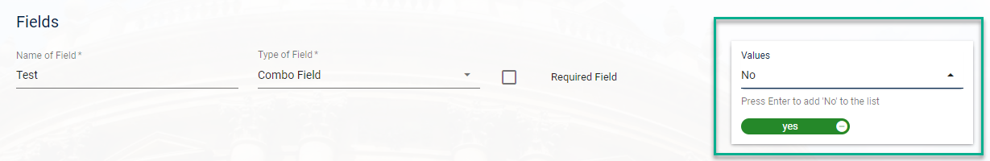

Combo Field (Ref Data) – allows for the survey to be linked to any pre-existing reference data item. Those items will then appear as a drop down for the individual to select from when completing the task.

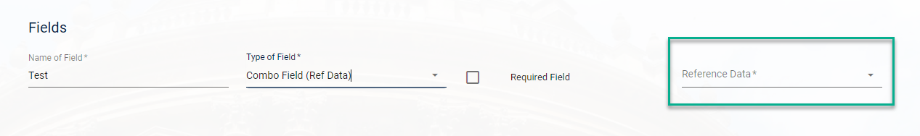

When 'Combo Field (Ref Data)' is selected under 'Type of Field' a new Reference Data* field will appear that contains the list of available items. Select the relevant item from the drop-down list.

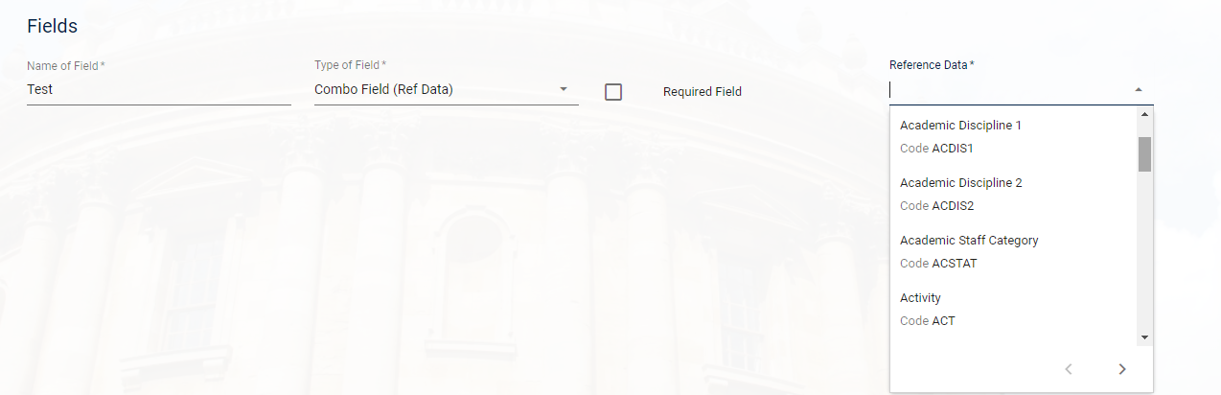

Radio Group - allows manual entry of possible responses that can be selected from when completing the survey. Only one response can be selected.

Enter one possible response in the 'Values' field then press enter/return. The text will appear in a green box. Repeat until you have entered all the possible responses you wish to appear in the survey.

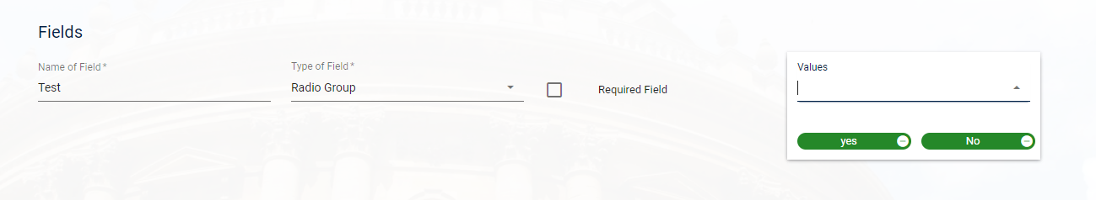

Slider Field – enables a sliding scale. Enter the maximum value. NB this has not been configured in our pilot survey.

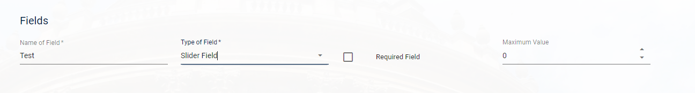

- To add further sections, repeat the steps above

Editing a survey

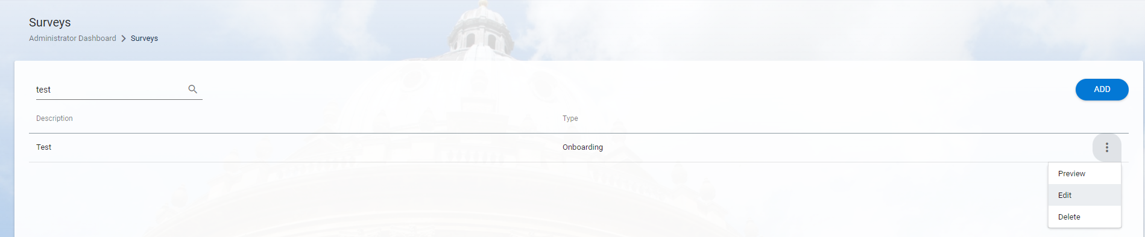

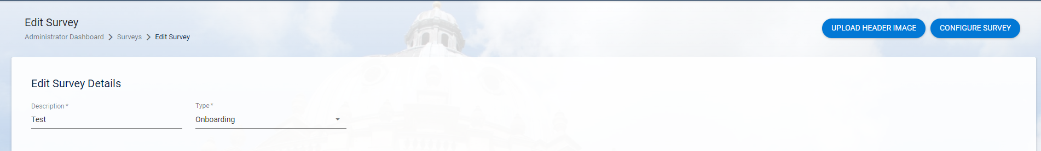

Landing page configuration
Follow the steps in Section B to create custom pages which can be added to the Landing page following the steps below:

Administrator Dashboard > Admin > Social Hub Configuration > Landing Page Configuration

- Click on ADD PAGE

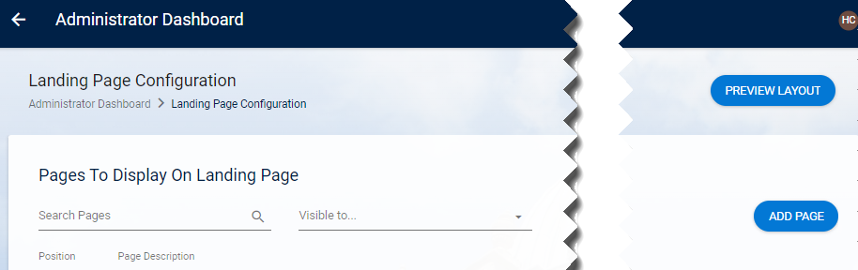

- Select Page Type then select your Custom Page from the list then OK | 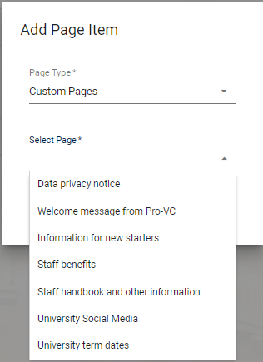
- To restrict the page to click on the ellipses and choose Restrict | 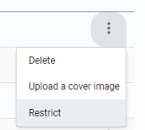
- Click on ASSIGN NEW GROUP and choose the group from the drop-down list | 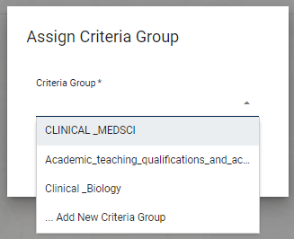
- If you wish to change the display order over-write the numbers or click into the number field and use the arrows to change the position | 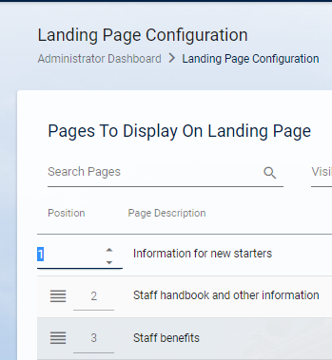
- To delete a page to click on the ellipses and choose Delete | 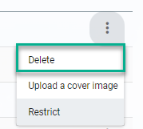

Staff Grouping
Staff grouping controls (restricts) which tasks are presented to the individual to complete based on certain criteria.

Administrator Dashboard>Admin>Social Hub Configuration>Staff Grouping

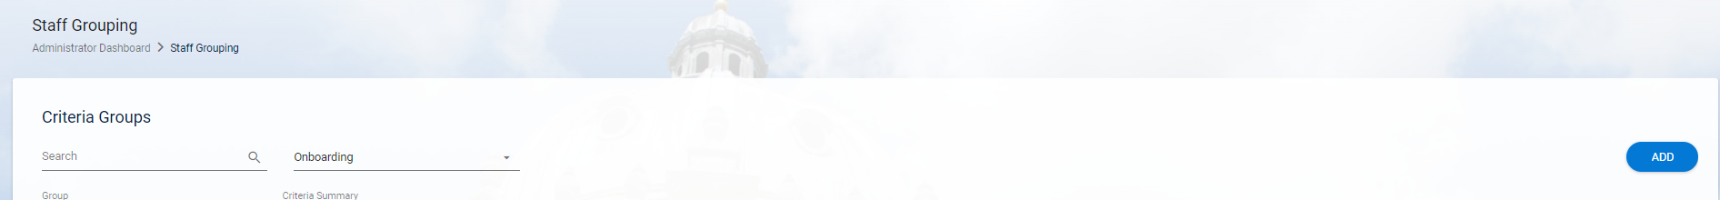

- Click ADD

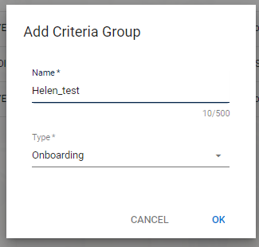

- Enter a Name for your Criteria Group

- Ensure the correct Type is selected (Defaults to Onboarding)

- Click OK

- Choose your first criterion from the options on the left-hand side

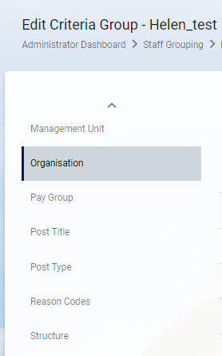

- To assign the individual items, click on each item you want to assign from the 'Available' section and then click on the > to assign them to the group

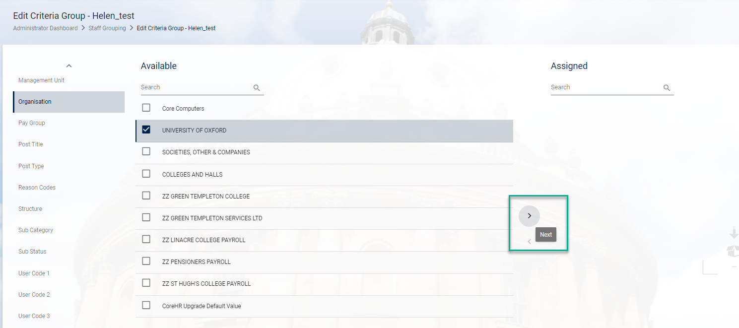

 | NB: If the list of available items is too long you can narrow down the results by entering all or part of the name in the search box.

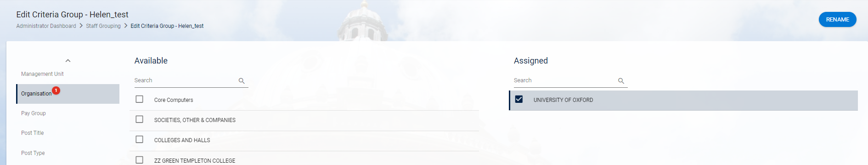

- The selected items now appear under 'Assigned'.

 | NB: you will now see a numbered red dot displayed next to the criterion. This denotes the number of criteria selected under that section.

- Repeat the steps above for each item to be added to the Criteria Group

- Once you have added all of the criteria, click on the breadcrumb trail to return to the Criteria Groups landing page

- Your Criteria Group will now appear in the list.

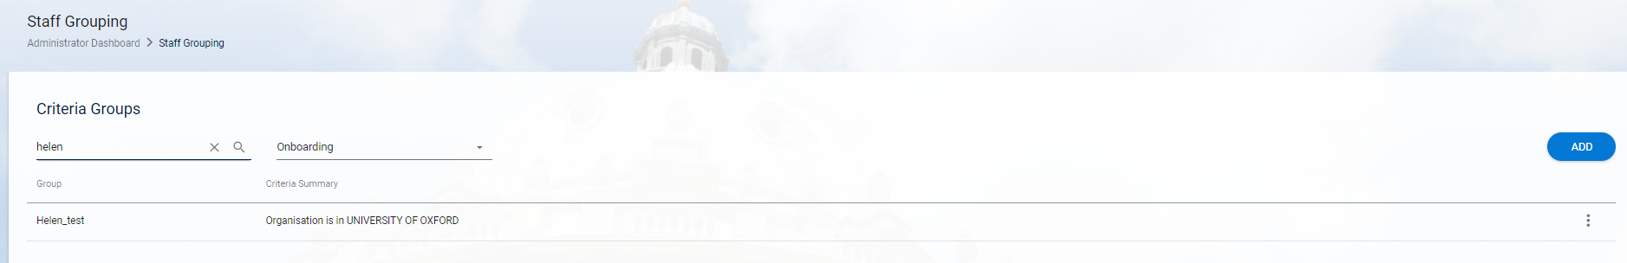

Adding items to the Checklist

Adding an Input item

Administrator Dashboard > Admin > Social Hub Configuration > Checklist

- Click on VIEW | 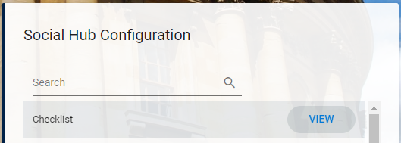
- Click on ADD ITEM | 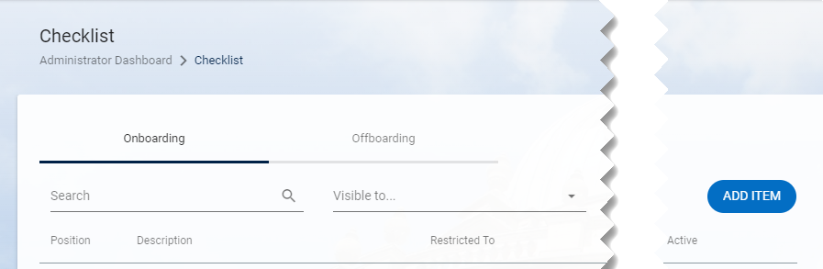

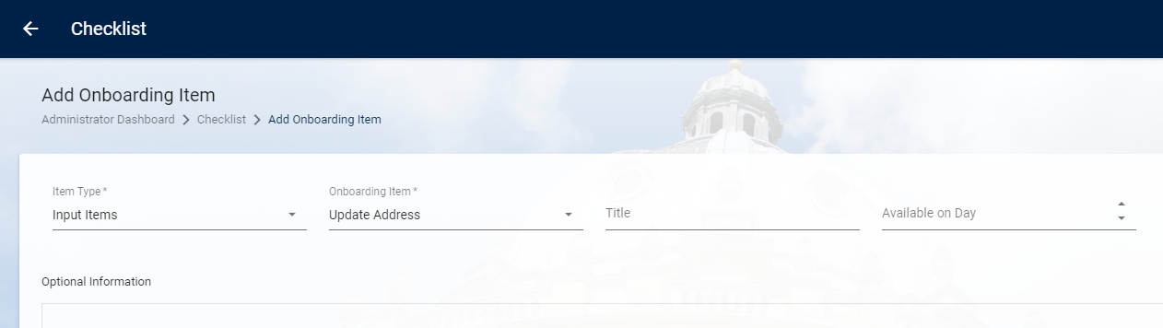

Enter details as follows:
Item | Comments
Item Type * | Select 'Input Items' from the drop-down list.
Onboarding Item* | Select the relevant item from the drop-down list
Title | Enter a Title (this is what the employee will see)
Available on Day | Enter the relevant day, usually 0 (this determines how many days after their start date the employee will see this item)
Optional Information | Enter text and format as required. Editing tools are available as shown.  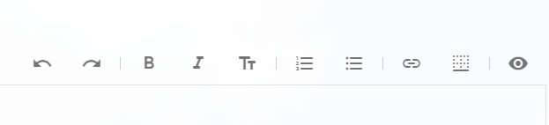

- To change the font size, click on the TT symbol and choose Heading, Sub Heading or Normal | 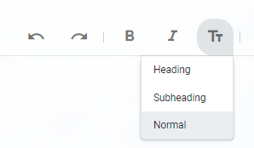
- To insert a hyperlink, click on the in the editing tools.  - Enter the Title*  - Enter or past the URL*  - Click OK to save and return to the editing screen  - SAVE | 

- To preview your custom page, click on the ellipses (…) and choose 'Preview'

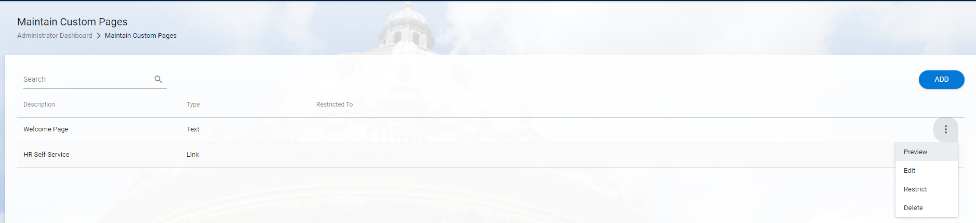

 | NB: The cover image isn't displayed on the preview

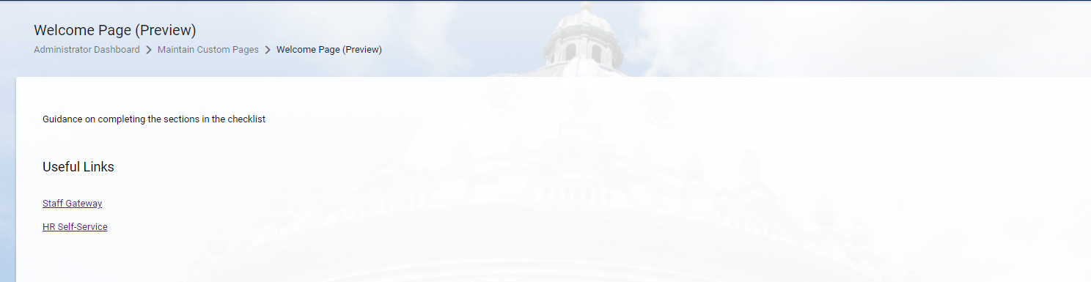

 | Guidance on adding a custom page to the checklist can be found in Section C

Adding a UDF item

Administrator Dashboard > Admin > Social Hub Configuration > Checklist
- Click on VIEW | 
- Click on ADD ITEM | 

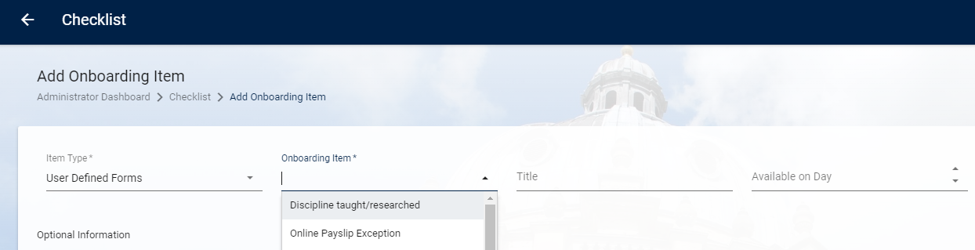

- Enter details as follows:
Item | Comments
Item Type * | Select 'User Defined Forms' from the drop-down list
Onboarding Item* | Select the relevant UDF from the drop-down list
Title | Enter a Title (this is what the employee will see)
Available on Day | Enter the relevant day, usually 0 (this determines how many days after their start date the employee will see this item)
Optional Information | Enter text and format as required. Editing tools are available as shown.  

- SAVE

Adding a survey

 | Guidance on creating surveys is in section C3

Administrator Dashboard > Admin > Social Hub Configuration > Checklist

- Click on ADD ITEM

- Under Item Type select 'Surveys' from the drop-down list.

- In the Onboarding Item field choose the relevant survey from the drop-down list.

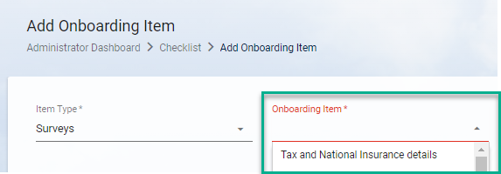

! Don't add any text in the Optional Information section as this will not be displayed on the checklist. All text required for a survey must be entered in the survey configuration screens.

Restricting access to tasks using the Staff Groups
This

Activate
This is the last step and once you have activated the checklist it will immediately be visible to eligible employees in ESS.

An overnight job will run to mark the tasks for all ineligible employees as completed.

Go to Administrator Dashboard > Admin > Social Hub Configuration >Activate

- Click VIEW

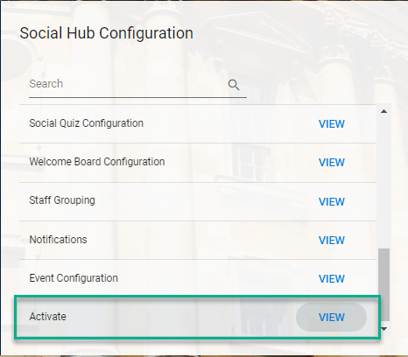

- Click on Enable

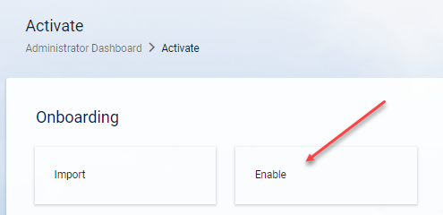

- Enter the Start (Effective) Date and click ENABLE

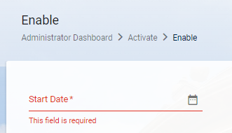

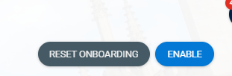

 | NB: As soon as you have clicked ‘enable’ the job will start to complete the checklists for all employees whose appointment started before the effective date.

